Heavy Duty Post Protectors
Protects pallet racks against forklift abuse. Made of heavy 7 gauge steel. Base plate is 8"W x 6"D, with a 4" column opening. 5/8" anchor holes are provided for a 1/2" diameter wedge anchors (supplied by others). Durable yellow powder coat finish. Taller post protectors available. Contact dealer for availability and pricing. Made in USA. FOB Chicago, IL 60639.
Product No. | Length |  | Weight (lbs.)
TP-12  TP-18  TP-24 | 12”  18”  24” |  | 10  16  25

Snap-On Upright Protectors  - Easy Snap-On Installation  - No Anchoring Required  - Reliable, tough and resilient BALLISTICS grade polymer.  - Retains its shape, ensures long & effective lifetime service.  - Fits all makes of pallet racking |  |  | 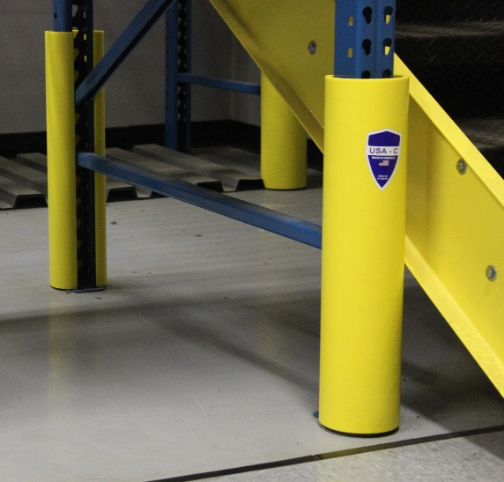
Cost effective protection for your racking. Reduces racking damage by as much as 80%, saving time, trouble, & money. Easy snap-on installation, fits in seconds, no tools or anchoring required. Virtually unbreakable in temperatures above 41°F and operates down to -40°F. Impervious to moisture, mold growth, corrosion, acid, alkaline, and most solvents. High visibility color with other colors available - quantity sensitive. Fully recyclable and non-toxic. Made in USA. FOB Chicago, IL 60639.
Product No. | Height | Column Size  W x D |  | Weight (lbs.) | Finish
RAG-A  RAG-B  RAG-C | 23 ½”  23 ½”  23 ½” | 3” x 1-5/8”  3” x 3”  3-3/16” x 2-3/8” |  | 2.6  3.3  3.6 | Yellow  Yellow  Yellow

