Pallet Rack Storage System Kits  - One Starter Unit to begin each row. Add-On Units to extend or complete row.  - Unit Widths are 8'-0", 9'-0", and 10'-0".  - Unit Depths are 42" or 48". Call for pricing on 36".  - Uprights: 8'-0", 10'-0", or 12'-0" high. Call for pricing on additional frame heights.  - 14'-0", 16'-0", or 20'-0" high units available.  - Two beam levels per unit. Call for pricing on additional beam levels.  - Welded frames: 3" x 1-5/8" columns.  - Capacity: 15,240 lbs per 48" of beam spacing  - Beam Capacities  - 8'-0" : 4,521 lbs per pair  - 9'-0" : 3,232 lbs per pair  - 10'-0" : 3,054 lbs per pair  - Units available with or without decking. Made in USA. Lead time 2-3 days. FOB Chicago, IL 60639. |  |  |  | 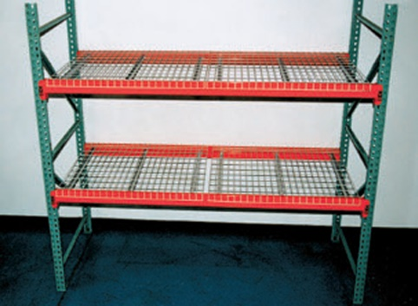  Starter Kit  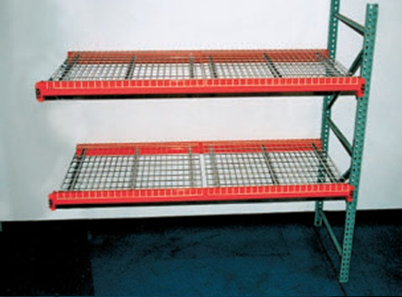  Add-On Kit
 | STARTER UNIT INCLUDES  2 Frames, 4 Beams,  & 4 Wire Decks |  | ADD-ON UNIT INCLUDES  1 Frame, 4 Beams,  & 4 Wire Decks |  |  | EXTRA SHELF INCLUDES  2 Beams,  & 2 Wire Decks
Upright  D x H | Product  No. | Wt. (lbs.) | Product  No. |  | Wt. (lbs.) | Product  No. | Wt. (lbs.)
8’W UNITS WITH WIRE DECK (WT. CAP. 16,200 LBS.)*
36” x 96”  36” x 144” | POW401  POW403 | 262  304 | POW407  POW409 |  | 217  238 | XS36096WD  XS36096WD | 86  86
42” x 96”  42” x 120”  42” x 144” | POW501  POW502  POW503 | 268  282  323 | POW507  POW508  POW509 |  | 235  245  257 | XS42096WD  XS42096WD  XS42096WD | 94  94  94
48” x 96”  48” x 120”  48” x 144” | POW601  POW602  POW603 | 283  297  339 | POW607  POW608  POW609 |  | 249  257  271 | XS48096WD  XS48096WD  XS48096WD | 100  100  100
9’W UNITS WITH WIRE DECK (WT. CAP. 16,200 LBS.)*
42” x 120”  42” x 144” | POW701  POW702 | 306  330 | POW705  POW706 |  | 249  261 | XS42108WD  XS42108WD | 96  96
48” x 120”  48” x 144” | POW703  POW704 | 322  350 | POW707  POW708 |  | 265  279 | XS48108WD  XS48108WD | 104  104
10’W UNITS WITH WIRE DECK (WT. CAP. 16,200 LBS.)*
42 x 120”  42 x 144” | HPOW801  HPOW802 | 346  370 | POW805  POW806 |  | 289  301 | XS42120WD  XS42120WD | 116  116
48 x 120”  48 x 144” | HPOW803  HPOW804 | 358  386 | POW807  POW808 |  | 301  315 | XS48120WD  XS48120WD | 122  122
*Capacity based on 48” beam spacing.

