Teardrop Pallet Rack & Beams  - Heavy duty steel in all upright frames  - Engineered and built for safe, sturdy support  - Teardrop style allows for interchangeability of beam sized  - Welded green uprights and orange beams are in stock  Made in USA. FOB Chicago, IL 60639. |  | 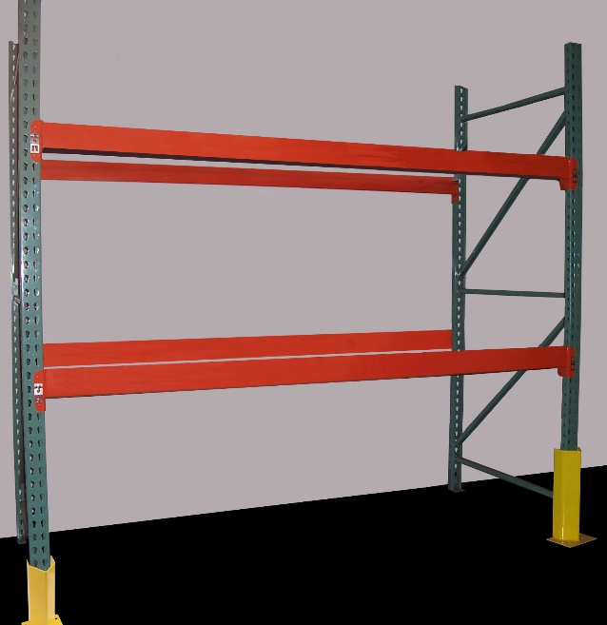
TEAR DROP ROLL FORM – OPEN BACK UPRIGHTS
Product  No. | Size  D x W |  | Wt.  (lbs.) | Cap.**  (lbs.)
FS08-24-96 | 24 x 96” |  | 41 | 16,200
FS08-36-96  FS08-36-144 | 36 x 96”  36 x 144” |  | 45  66 | 16,200  16,200
FS08-42-96  FS08-42-120  FS08-42-144  FS20-42-168  FS20-42-192  FS20-42-240 | 42 x 96”  42 x 120”  42 x 144”  42 x 168”  42 x 192”  42 x 240” |  | 47  57  69  95  110  145 | 16,200  16,200  16,200  23,200  23,200  23,200
FS08-48-96  FS08-48-120  FS08-48-144  FS20-48-192  FS20-48-240 | 48 x 96”  48 x 120”  48 x 144”  48 x 192”  48 x 240” |  | 49  57  71  114  141 | 16,200  16,200  16,200  23,200  23,200

TEAR DROP BEAMS
Product  No. | Length | Wt.  (lbs.) | Cap.**  (lbs.)
SB3016-048 | 48” | 11 | 6,437
SB3016-096  SB3716-096  SB4116-096  SB4616-096 | 96”  96”  96”  96” | 20  22  24  26 | 3,017  4,409  5,220  5,953
SB4116-108  SB5016-108 | 108”  108” | 27  31 | 4,314  6,344
SB4616-120  SB5016-120 | 120”  120” | 32  42 | 4,517  5,661
SB5556-144  SB6014-144 | 144”  144” | 43  54 | 4,810  6,588

Accessories
Crossbars  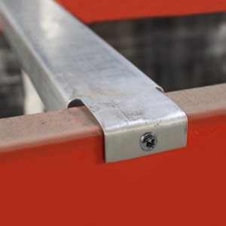 | Product No. | Length | Wt. (lbs.) | Finish
 | SR10106FSG  SR10112FSG | 6”  12” | 2  4 | Galvanized  Galvanized
Row Spacers  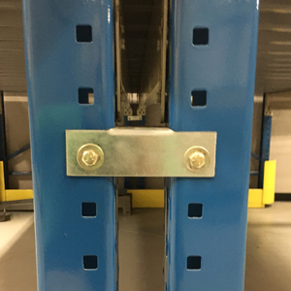 | Product No. | Length | Wt. (lbs.) | Finish
 | SR2016-36DFG  SR2016-42DFG  SR2016-48DFG | 36”  42”  48” | 5  6  7 | Galvanized  Galvanized  Galvanized
Standard Size  Accessories | Shims  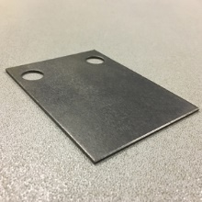 |  | Anchors  