Pallet Rack Wire Deck
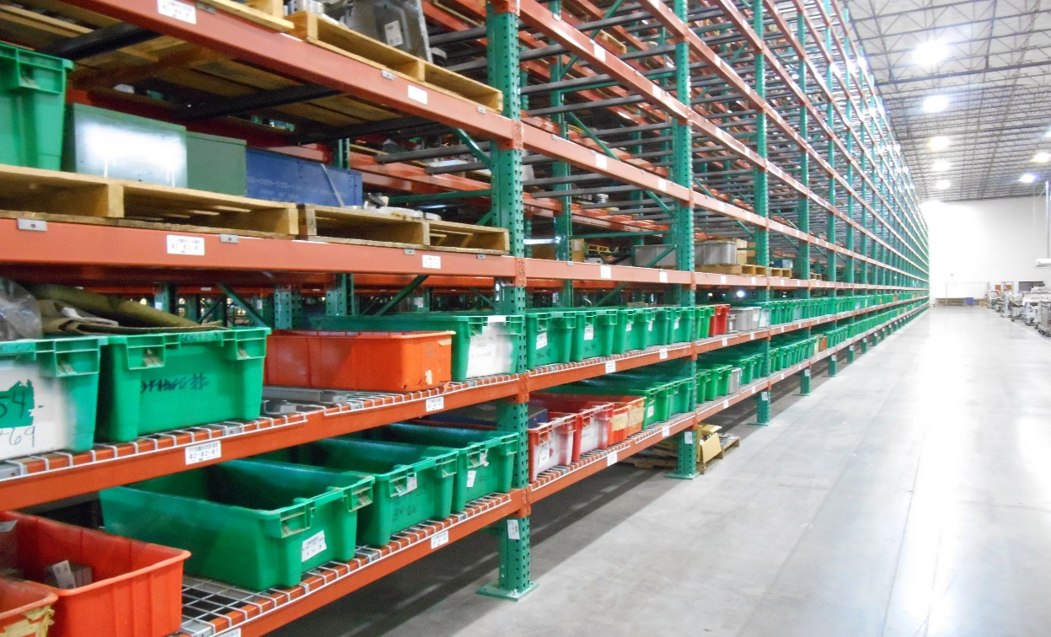
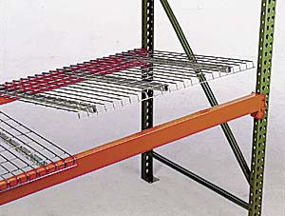 |  | - Step Channels fit in Step-down beams.  - Load capacities are based on evenly distributed loads.  Step Channel Decks have (3) standard support channels that fit into the step-down ledges of the pallet rack beams. Call for pricing on flared channel wire deck. FOB Shipping Point.
Product  No. | Length |  | Wt.  (lbs.) | Cap.**  (lbs.)
WD36463CWPI6 | 36 x 46” |  | 21 | 2,200
WD42463CWPI6  WD42523CWPI6  WD42583CWPI6 | 42 x 46”  42 x 52”  42 x 58” |  | 24  26  31 | 2,500  2,500  2,500
WD48463CWPI6  WD48523CWPI6  WD48584CWPI6* | 48 x 46”  48 x 52”  48 x 58” |  | 27  33  36 | 2,500  2,500  2,500
*48” x 58” wire decks have (4) channels to meet the 2,500 lbs. capacity.

